The Bluebottle Jellyfish

The blue bottle feeds on small fish and other small ocean creatures. They envelope their prey with their tentacles, where a poison is released thus paralysing its prey before being consumed. The tentacles adhere extremely well to their prey. If a tentacle is put under the microscope you will see that it looks like a long string of barbed hooks, which explains the ability of the tentacle to attach.
If a tentacle attaches itself to a human, it releases a poison (through the use of nematocysts), and if you continue to rub the skin after the tentacle has been removed more poison or venom will be released. If you are stung, it is best to wash the area without touching. A cold pack should be used to relieve the pain. If stung, please consult a doctor immediately. No fatalities have ever been reported within Australia or New Zealand from the sting of a blue bottle.
The blue bottles colour can range from a blue to a pink hue, with a transluscent body. The float or body of the blue bottle measures between 3 to 15 cms. The tentacles can range in length from 15 cms up to 10 metres!.

The way it stings is by as shown here it puts its tentecals around it and stings it
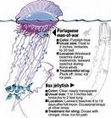

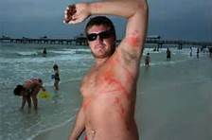
If stung you look like this man above

Also it will float round like this
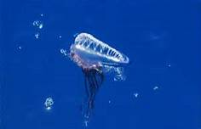it will float round with its tentacals trailing behind it
This jellyfish is actually made up of zooids. The blue bottle is not a single organism, but made up of a number of zooids. Each zooid has a specific role and together they function as if it were an animal. For example a number of zooids will make up the stinging tentacles, others will make up the feeding tentacles. It will only sting people if it thinks its under attack and will only sting its prey purposely. It stinging humans is its own form of defence

In Australia and New Zealand, this jellyfish is known as the blue bottle, due to its colour and shape when strewn on a beach. Elsewhere in the world it is known as the "Portuguese Man o War" as it is said to look like a Portuguese battleship with a sail.

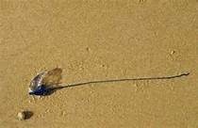
A washed up bluebottle

The thing that made me want to do this was at brighton beach there was tons of blue bottles washed up on the shore and in the water 